
Saint Michael College, Cantilan, Incorporated
Cantilan, Surigao del Sur
College Department

LEARNING MODULE
in FS II

- MODULE 3: INSTRUCTIONAL RESOURCES

- LEARNING ACTIVITIES (Use a separate sheet of paper)
Task 1: Request a permission to conduct an interview with teachers. Identify the instructional resources used by teachers in teaching and learning.
- What are the types of instructional resources used by teachers to motivate learners about the lesson?
Based on the interview, teachers use the following resources to motivate learners:
- Pictures and flashcards related to the topic
- Short motivational videos or animated clips
- Real objects (realia) such as fruits, toys, school supplies, etc.
- Songs and action videos to capture interest
- Interactive PowerPoint slides with colorful visuals
These resources help activate prior knowledge and catch the attention of Grade 2 learners.
- What are the types of instructional resources used by teachers in the delivery of the content of the lessons?
Teacher Christy uses a combination of:
- PowerPoint presentations
- Printed modules or activity sheets
- Teacher-made charts and posters
- Storybooks and big books
- Worksheets
- Learning videos aligned to the MELCs
- Digital tools, such as DepEd Commons and YouTube educational channels
These materials help explain the concepts clearly and support varied learning styles.
- What types of instructional resources are used by teachers in the assessment of students’ academic performance?
For assessment, the following are commonly used:
- Written quizzes and tests
- Performance tasks and activity sheets
- Rubrics for evaluating outputs
- Oral drills and recitations
- Checklists for monitoring skills and competencies
- Digital quizzes (Kahoot, Quizziz—if technology is available)
These help measure learners’ understanding and mastery of the lesson.
- What are the types of resources used by teachers in practical applications?
Teachers use:
- Manipulatives (counters, blocks, sticks, coins)
- Real-life objects (measuring tools, plants, household items)
- Hands-on activity materials (art supplies, science experiment tools)
- Learning centers or stations for group activities
- Project materials used for creating outputs or demonstrations
These resources allow learners to apply concepts in real-life and hands-on situations.

Task 2: Look for research journals and literatures that can be used as instructional resources for your chosen field of specialization or majors (textbooks, research journals). Use this format:
For Textbook : Name of Author(s)/ Year Published (write ND if there is no date indicated)/ Title of the Book/ Publisher/ City of Publication
• Colin Forster / 2020 / Teaching the Primary Curriculum / SAGE Publications / London. Amazon
• Russell Grigg / 2022 / Becoming an Outstanding Primary School Teacher: A journey, not a destination / Routledge / Abingdon (UK). Routledge+1
• Michelle Manes / 2017 / Mathematics for Elementary Teachers / University of Hawaiʻi at Mānoa (Open Textbook) / Honolulu. UH Pressbooks+1
For Research Journals: Name of Author(s)/ Year Published (write ND if there is no date indicated)/ Title of Research/ Publisher/ City of Publication
• N. K. A. Farra / 2024 / Impact of using virtual and concrete manipulatives on elementary mathematics learning / Taylor & Francis (Cogent Education) / (online journal). Taylor & Francis Online
• A. Milenković / 2025 / The impact of discovery-based learning with physical manipulatives in early mathematics education / ERIC / (online). ERIC
• M. A. Biscocho & A. J. Roy / 2024 / The Use of Video-Based Instructional Material to Improve Learning Competency / Psychology and Education: A Multidisciplinary Journal / (online journal). Philippine EJournals
• (Author(s) vary) / 2022 / Utilization of Instructional Materials Developed by the Mathematics Teachers in Public Secondary Schools in Sorsogon / AJOuR Online / (Sorsogon study; useful for local context on teacher-made materials). ajouronline.com

Task 3: Create a short video clip about a specific lesson using ICT tools. Write your experience in creating the video. (Send the video clip through messenger or gmail.)

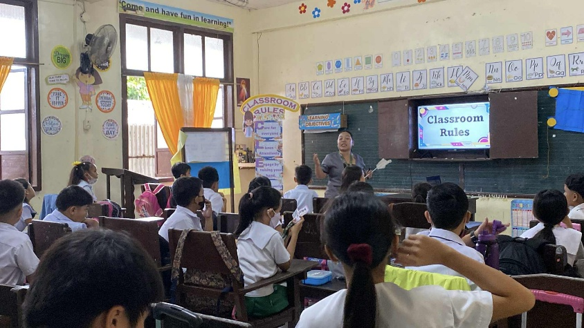

Task 4: Prepare presentation slides regarding topic using PowerPoint or other presentation softwares. Describe the process of creating presentation slides. Print the slides and submit the softcopy via messenger or gmail.

Process of Creating the Presentation Slides
- Planning the Content
I started by identifying the main topics and key points that I needed to include in the presentation. I organized the information into an outline to ensure that each slide would focus on only one idea. This helped me maintain clarity and flow throughout the presentation.

- Choosing a Presentation Software
I used Microsoft PowerPoint (or Canva/Google Slides—choose one) because it is accessible and easy to use. I selected a simple and professional slide template to make the presentation visually appealing.

- Designing the Title Slide
I created a title slide that included the topic, my name, my grade level (Grade 2 practice teacher), and the name of my cooperating teacher. I chose a clean background and readable fonts to ensure clarity.

- Creating the Content Slides
I added new slides and arranged my main points using bullet points, short phrases, and visual aids. I avoided long paragraphs to keep the slides easy to understand. I also inserted pictures, icons, or illustrations to make the content engaging for students.
- Applying Design Principles
I applied basic design principles such as:
  - Consistent font style and size
  - Using contrasting colors for readability
  - Keeping enough white space
  - Aligning text and images properly
These helped the slides remain clean and organized.

- Adding Media Elements
When necessary, I inserted graphics, shapes, and simple transitions. I made sure the transitions were not too distracting and that the visuals supported the lesson content.
- Reviewing and Finalizing
I reviewed the entire slide deck to check for spelling, grammar, and layout errors. I removed unnecessary elements and ensured the content was appropriate for Grade 2 learners. After finalizing, I saved the file in PPTX and PDF format.
Task 5: Visit the DepEd Learning Portal through https://lrmds.deped.gov.ph/k_to_12. Check and observe how the learning portal is designed. Describe your experience in accessing information from the portal. Write down your observation.
During my visit to the DepEd Learning Portal (LRMDS) at https://lrmds.deped.gov.ph/k_to_12, I explored how the platform is designed to support teachers in accessing K–12 learning and teaching resources. Upon opening the portal, I observed that it provides a clean and organized layout where users can browse resources by grade level, subject area, and type of material. The registration page requires basic information such as name, email, and school affiliation, and I noticed that some materials can only be downloaded using a DepEd email account. As I navigated through the site, I saw a variety of digital resources including lesson plans, activity sheets, modules, storybooks, and media files like photos and videos. The portal functions as a centralized repository that helps teachers easily locate materials aligned with the curriculum.
My experience in accessing the information was generally smooth and user-friendly. The search and filtering options made it convenient to find Grade 2 resources that I could use for classroom instruction. I appreciated that many materials were ready for printing or downloading, which is helpful for planning lessons and creating activities. However, I also observed some limitations, such as occasional loading delays and restricted access to certain resources that require DepEd verification. Despite these minor challenges, I found the portal very useful because it offers a wide range of instructional materials that can support teaching and learning. Overall, the DepEd Learning Portal is a valuable tool that helps teachers like me enhance classroom instruction through accessible and curriculum-aligned digital content.
Task 6: Using a Venn diagram below, identify the advantages of using graphic organizers compared to other forms of instructional resources.
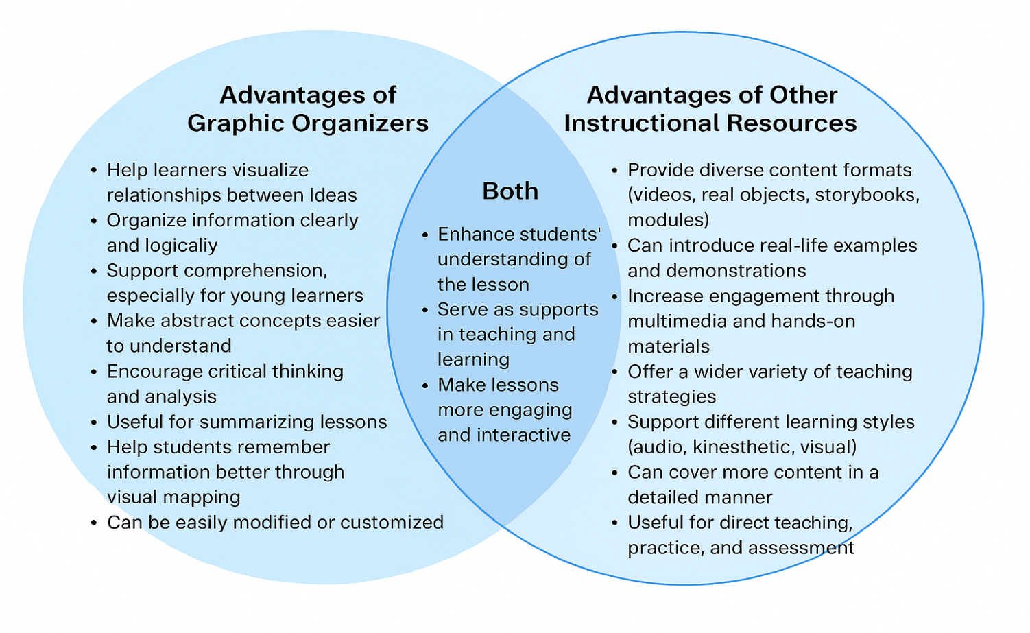

- SELF-EVALUATION

Reflection
I realized that exploring different instructional resources, including digital materials and graphic organizers, plays a very important role in making lessons meaningful and engaging for learners. I also realized that each resource has its own strengths, and choosing the right one can help address the diverse learning needs of my Grade 2 pupils. Through the activities in this module, I understood how instructional resources support clearer explanations, better comprehension, and more active participation inside the classroom.
I believe it is essential to carefully select, organize, and prepare instructional materials that align with the learning objectives and the developmental level of the learners. It is also essential to become resourceful as a teacher by maximizing trusted platforms, such as the DepEd Learning Portal, and by creating materials that suit the context of my class. Doing this will help make my teaching more effective and responsive to learners’ needs.
From now on, I am determined to use a wider variety of instructional resources and continuously improve my skills in designing engaging materials for my students. I am also committed to exploring more digital tools and teaching strategies that will enhance my lesson delivery and make learning more interactive for my pupils. Most importantly, I will apply everything I learned in this module to become a more prepared, creative, and effective future teacher.

- TEST : Write your answer in a separate sheet of paper.

- How essential is the use of varied instructional resources to teaching and learning?
Varied instructional resources are very important in Grade 2 because young learners have different ways of understanding. Using storybooks, pictures, flashcards, videos, and hands-on activities makes lessons more interesting and helps students understand concepts better.

- How do educational research and literatures help improve the content of the lesson?
Educational research and literature guide teachers on the best ways to teach Grade 2 students. They provide ideas, strategies, and activities that are proven to help young learners understand lessons and stay engaged.

- How does digital media impact student learning?
Digital media helps Grade 2 students learn by showing them colorful images, animations, and interactive activities. It makes lessons fun, easy to understand, and allows students to practice skills like reading, math, and problem-solving on tablets or computers.

- What are the advantages and disadvantage of using digital media in teaching and learning?
Advantages | Disadvantages
• Makes learning fun and interesting.  • Shows concepts in pictures or videos that are easy for children to understand.  • Lets students practice skills through games and activitie | • Students can get distracted if not monitored.  • Requires devices and internet access, which may not always be available.  • Some students may rely too much on technology instead of thinking independently.

- Draw a concept map about graphic organizers. Identify the benefits of using graphic organizers in student learning.
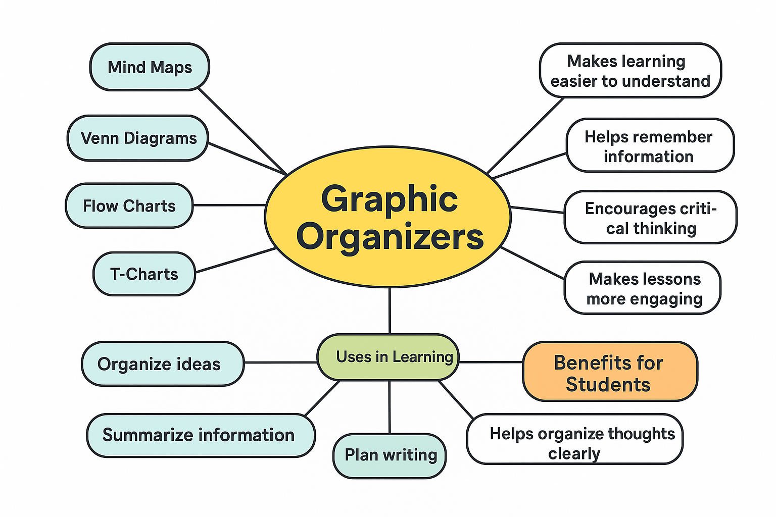

- What is the primary consideration in developing and producing teacher-made resources?
  - The main consideration is making resources suitable for Grade 2 learners. They should match the lesson objectives, be easy to understand, colorful, engaging, and support the students’ learning needs.

